Section 11.1 – Permutations
(1) The ski club with ten members is to choose three officers captain, co-captain & secretary, how many ways can those offices be filled?

(2) Suppose you are asked to list, in order or preference, the three best movies you have seen this year. If you saw 10 movies during the year, in how many ways can the three best be chosen and ranked?

(3) In the Long Beach Air Race six planes are entered and there are no ties, in how many ways can the first three finishers come in? In how many ways can they all come in?

(4) In a production of Grease, eight actors are considered for the male roles of Danny, Kenickie, and Marty. In how many ways can the director cast the male roles?

(5) Seven bands have volunteered to perform at a benefit concert, but there is only enough time for four of the bands to play. How many lineups are possible?

Practice: Expand and evaluate.
(6) ₈P₄ | (7) ₁₁P₁₀ | (8) ₉P₃

Section 11.1 -- Combinations:
(1) There are 12 different-colored cubes in a bag. How many ways can Josh draw a set of 4 cubes from the bag?

(2) The swim team has 8 swimmers. Two swimmers will be selected to swim in the first heat. How many ways can the swimmers be selected?

Practice: Identify if the question uses the Fundamental Counting Principle, Permutation, or Combination. Then answer the question.
(3) In a talent show, the top 3 performers of 15 will advance to the next round. In how many ways can this be done?

(4) Six different books will be displayed in the library window. How many different arrangements are there?

(5) The three best essays in a contest will receive gold, silver, and bronze stars. There are 10 essays. In how many ways can the prizes be awarded?

(6) The soccer team is silk-screening T-shirts. They have 4 different colors of T-shirts and 2 different colors of ink. How many different T-shirts can be made using one ink color on a T-shirt?

(7) A travel agent is offering a vacation package. Participants choose the type of tour, a meal plan, and a hotel class from the table below. How many different vacation packages are offered?
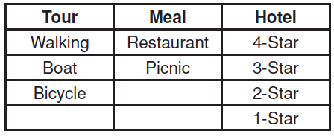

(8) In how many ways can the debate team choose a president and a secretary if there are 10 people on the team?

