3/15/16
Special Polar Graphs
9.2
L21
Warm-up
Complete the table

$$y=2-cosθ$$
$$θ$$ | y
$$0°$$
30$°$
45$°$

60$°$
90$°$
120$°$
135$°$
150$°$
180$°$

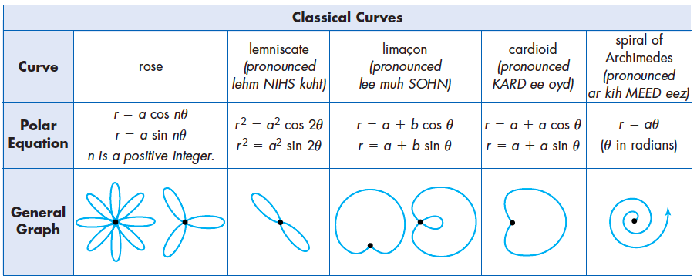

Plot points. Sketch graph.

Exit Ticket, sketch a graph of $r=2sin3θ$. Identify what type of graph it is.

