.
Working with Matrices

Matrices are rectangular arrays of elements.
The dimension of a matrix is the number of rows by the number of columns.

Adding/ Subracting Matrices - matrices must be of the same dimension to be added/ subtracted.
Add:
First Enter the Matrices (one at a time):

Step 1: Go to Matrix  (above the x⁻¹ k key) | Step 2: Arrow to the right to  EDIT to allow for entering the matrix. | Step 3: Type in the dimensions (size) of your matrix and enter the elements (press ENTER).
Step 4: Repeat this process for  the second matrix  . | Step 5: Arrow to the right to  EDIT and choose a new name. | Step 6: Type in the dimensions (size) of your matrix and enter the elements (press ENTER).
Now, add:  Step 7: Return to the home screen. Go to Matrix to get the names of the matrices for adding. | The answer to the addition, as seen on the calculator screen,  is =
Multiplying Matrices - for multiplication to occur, the dimensions of the matrices must be related in the following manner: m x n times n x r yields m x r
Multiply:
First Enter the Matrices (one at a time) as shown above:

Step 1: Once the matrices are entered, you should see their dimensions in residence when you go to Matrix (above the x⁻¹ key) | Step 2: Return to the home  screen. Go to Matrix to get the names of the matrices for multiplying. | The product, as seen on the calculator screen,  is =

Using Matrices to Solve Systems of Equations: (using Gauss-Jordan elimination method with reduced row echelon form )
Solve this system of equations:
2x - 3y + z = -5
4x - y - 2z = -7
-x + 2z = -1

Step 1: Line up the variables and constants  2x - 3y + z = -5  4x - y - 2z = -7  -x +0y + 2z = -1 | Step 2: Write as an augmented  matrix and enter into calculator. (3 x 4 matrix) | Step 3: From the home screen, choose the rref function. [Go to  Matrix (above the x⁻¹ key), move right→MATH, choose B: rref]
Step 4: Choose name of matrix  and hit ENTER. | Step 5: The answer to the system, will be the last column on the calculator screen:  x = -3  y = -1  z = -2.

Adding/ Subtracting Matrices using Graphing Calculator

1)
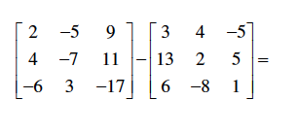

2)

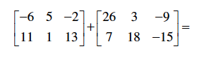

Multiplying Matrices using Graphing Calculator

3)

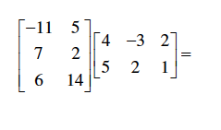

4)

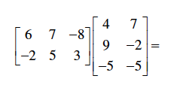

Solving systems of Equation using Graphing Calculator

5)

6)

Pre Calculus TABLE #________
Lesson 8 Graphing Calculator Activity PERIOD ________

Adding/ Subtracting Matrices using Graphing Calculator
1) 2)

Multiplying Matrices using Graphing Calculator
3) 4)

Solving Systems of Equations using Graphing Calculator
5) 6)

