1. When a bottle of water is put into the freezer its temperature was 80º F. After 2 hours, its temperature is approximately 60ºF.
a. Write two ordered pairs, where x represents the time (in hours) since the bottle was put into the freezer and y represents the temperature (in degrees Fahrenheit) of the bottle of water at that time.
b. Find the average rate of change of the temperature of the bottle of water from when it is first removed from the freezer to 2 hours later.

c. Write a function T(t) that would model the bottle of water’s temperature T at any time t.
d. What is the temperature, rounded to the nearest degree, of the bottle of water after 4 hours?

2. Ricky is buying two kinds of pizza for a party. A pepperoni pizza costs $8 and a combo pizza costs $7. Ricky needs to buy at least 6 pizzas. The cost of the pizzas can be no more than $56. Let x represent the number of pepperoni pizzas and y represent the number of combo pizzas.
a. Write a system of inequalities to model this situation.

b. Determine whether it is possible for Ricky to buy 2 pepperoni pizzas and 4 combo pizzas. Show all your work.

c. Graph the system of inequalities that you created in question #2a.
3. Let g(x)= |x| and k(x)= x+1|-2.
a. Describe the transformations of k(x) from the parent function g(x)= |x|.

b. Graph both g(x) and k(x) on the coordinate axis below.
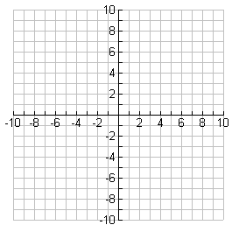
State the domain and range of both g(x) and k(x).
c. Domain of g(x):____________ d. Range of g(x):_____________
e. Domain of k(x):____________ f. Range of k(x):______________

4. Given $F\left(x\right)=-3x+1, write the inverse function and graph both functions.$
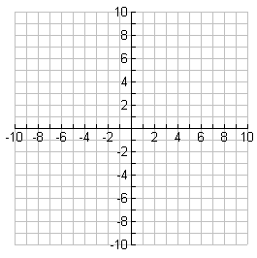
5. Let $y=x$ and $y=\frac{3}{4}x+1$.
a. Graph both equations.
b. Using the graph above find the solution that satisfies both equations

6. Use the spreadsheets below showing the daily income and the daily expenses for a new business.
Day | Income
1 | $100
2 | $200
3 | $300
4 | $400
Day | Expense
1 | $1800
2 | $1600
3 | $1400
4 | $1200

a. Find a linear model for the daily income.

b. Find a linear model for the daily expenses.

c. Use the models to estimate the day in which income will equal expenses. Round your answer to the nearest day.

Given f(x) = 16x² – 1 and g(x) = 4x – 1,
find each function or value.
7.f(x) - g(x)=

$8. f(x)∙g(x)$=

$9.f(x)÷g(x)$=

10. g(f(-3))=

- f(g(x)) =

- g(f(1)) =

- $g^{-1}\left(x\right)=$

