Graph the parent function and the given absolute value function on the same graph. Identify the vertex and describe how the given absolute value function has moved with relation to the parent function. Use different colors to differentiate between the equations.

1. g(x) = | x | + 1 2. g(x) = | x | - 4

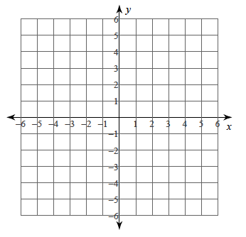
Vertex: Vertex:
Description: Description:

3. When you have a number added or subtracted to the outside of the absolute value function what happens? How is it related to the vertex?

4. g(x) = | x + 2 | 5. g(x) = | x – 3 |

Vertex: Vertex:
Description: Description:

6. When you have a number added or subtracted to the inside of the absolute value function what happens? How is it related to the vertex?

7. g(x) = | x - 2 | + 1 8. g(x) = | x + 4 | - 3
Vertex: Vertex:
Description: Description:

9. When you have a number on the added or subtracted on the inside and outside of the absolute value function what happens? How is it related to the vertex?

10. g(x) = - | x - 3 | + 2 11. g(x) = - | x + 4 | - 1
Vertex: Vertex:
Description: Description:

12. When you have a negative number multiplied on the outside of the absolute value function what happens? How is it related to the vertex?

