13.3
Unit Circle
Warm-up
Solve for x and y

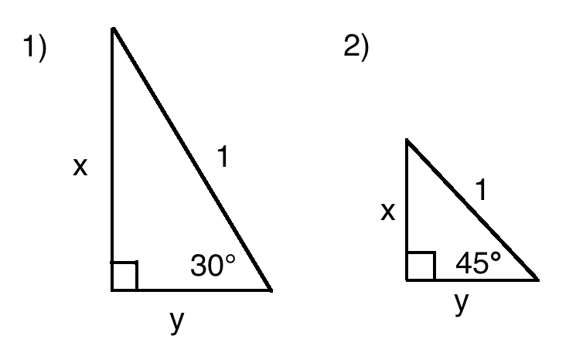

I do:
Use the unit circle to find the exact value of each trigonometric function.
- sin210$°$
cos210$°$
tan210$°$

Find the coordinates for the angle on the unit circle. | 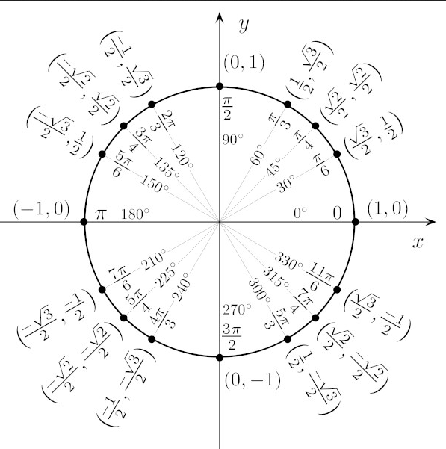  $$(-\frac{\sqrt{3}}{2},-\frac{1}{2})$$
$$sinθ=y$$  $$cosθ=x$$  $$tanθ=\frac{y}{x}$$ | $$sin210°=y=-\frac{1}{2}$$  $$cos210°=x=-\frac{\sqrt{3}}{2}$$  $$tan210°=\frac{y}{x}=-\frac{1}{2}÷-\frac{\sqrt{3}}{2}=$$  $-\frac{1}{2}∙\left(-\frac{2}{\sqrt{3}}\right)=\frac{1}{\sqrt{3}} ∙\frac{\sqrt{3}}{\sqrt{3}}$=$\frac{\sqrt{3}}{3}$

We try:
Use the unit circle to find the exact value of each trigonometric function.
$$sin\frac{2π}{3}$$
$$cos\frac{2π}{3}$$

$$tan\frac{2π}{3}$$

csc$\frac{2π}{3}$
sec$\frac{2π}{3}$
cot$\frac{2π}{3}$

Find the coordinates for the angle on the unit circle.
$$sinθ=y$$
$$cosθ=x$$
$$tanθ=\frac{y}{x}$$

You Try:
Even Write, Odd Talk
Use the unit circle to find the exact value of each trigonometric function.
$$sin90°$$
$$cos90°$$
$$tan90°$$

I do:
Use a reference angle to find the exact value of sine, cosine, and tangent of 225$°$

Find reference angle. | 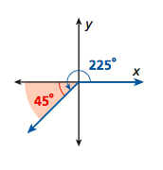
Find coordinates of reference angle. | 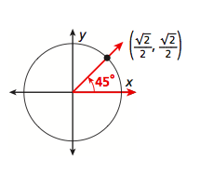  $$(\frac{\sqrt{2}}{2},\frac{\sqrt{2}}{2})$$
Adjust signs for the quadrant.  Q1(+,+)  Q2(-,+)  Q3(-,-)  Q4(+,-) | 225$°=Q3, (-,-)$  $$(-\frac{\sqrt{2}}{2},-\frac{\sqrt{2}}{2})$$
Solve for  sin$θ$=y  $cosθ$=x  tan$θ$=$\frac{y}{x}$ | Sin225$°=-\frac{\sqrt{2}}{2}$  Cos$225°$=$-\frac{\sqrt{2}}{2}$  Tan225$°=$1

We do:
Use a reference angle to find the exact value of sine, cosine, and tangent of 150$°$

Find reference angle.
Find coordinates of reference angle.
Adjust signs for the quadrant.
Q1(+,+)
Q2(-,+)
Q3(-,-)
Q4(+,-)
Solve for
Sin$θ$=y
$cosθ$=x
tan$θ$=$\frac{y}{x}$

You do with your partner.
Even Talk, Odd Write.
Use a reference angle to find the exact value of sine, cosine, and tangent of 330$°$

Find reference angle.
Find coordinates of reference angle.
Adjust signs for the quadrant.
Q1(+,+)
Q2(-,+)
Q3(-,-)
Q4(+,-)
Solve for
Sin$θ$=y
$cosθ$=x
tan$θ$=$\frac{y}{x}$

Closure:
Take a minute and think about the steps needed to find the exact value of sin150$°$. How would you solve it using the unit circle? How would you solve it using a reference angle.

Talk with your partner about the two methods.
Be prepared to share with the class.

