Binomial Distributions
11.6

Warm-up
Write Pascal’s Triangle to the 7th degree.

1
1 1
1 2 1

The Binomial Theorem is the expansion of Pascal’s Triangle.
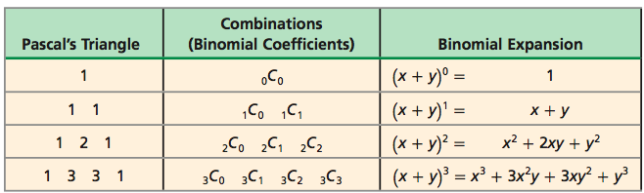

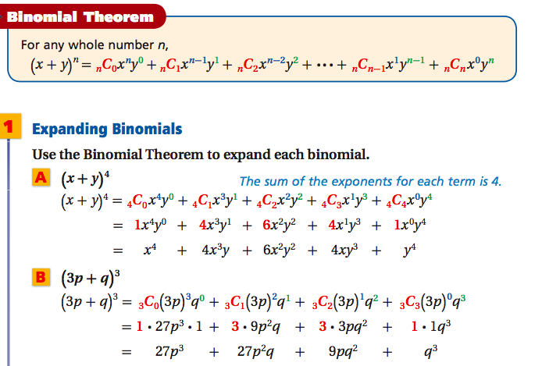

We Try:
Expand
- ${\left(x-y\right)}^{5}$

- ${\left(3x+2\right)}^{4}$

You Try:
Expand
$$1){\left(-x+3\right)}^{4}$$

A Binomial Experiment consists of n independent trials whose outcomes are either success or failures; the probability of success p is the same for each trial, and the probability of q is the same for each trial. Because there are only two outcomes, p+q=1.

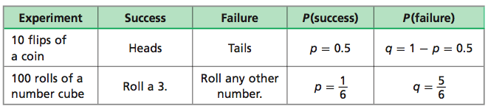

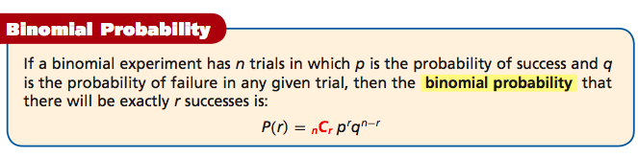

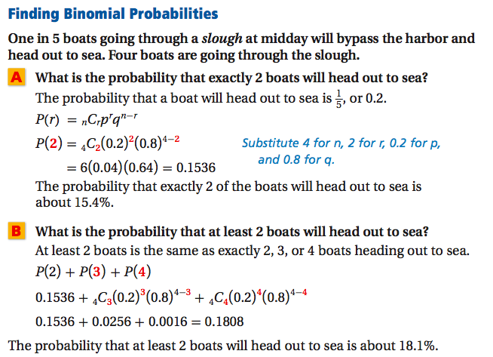

We Try:
Students are assigned randomly to 1 of 3 guidance counselors. What is the probability that Counselor Jen will get two of the next 3 students assigned?
$$P\left(r\right)=nCrp^{r}q^{n-r}$$

You Try:

Michael takes a multiple-choice quiz that has 5 questions, with 4 answer choices for each question. What is the probability that she will get at least 2 answers correct by guessing?

