Compound Events
11.4

A simple event is an event that describes a single outcome.

A compound event is an event made-up of two or more simple events.

Mutually exclusive events are events that cannot both occur in the same trial of an experiment.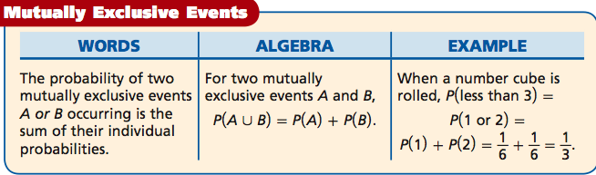

$∪=Union:$ The union of two sets A and B is the set of elements which are in A, in B, or in both A and B.
$$∩=Intersection$$: The intersection of two sets A and B is the set of elements in which are in both A and B only.

I do:
When Mr. Yen is not being a teacher of mathematics during class time, he is a teacher of humility during lunch and after school. There are many students in Mr. Yen’s classes who think they are good at Smash4. When they actually play Mr. Yen, both players start with three lives. The students always lose. Mr. Yen has a $\frac{2}{3}$ chance of not losing a single life and a $\frac{1}{6}$ chance of only losing one life, and $\frac{1}{6}$ chance of losing two lives.

- Explain why the events of Mr. Yen not losing a life or Mr. Yen only losing one life are mutually exclusive.

- What is the probability that Mr. Yen does not lose a single life or lost only one life?

We Do:
Each student cast one vote for senior class president. Of the 25% voted for Terri, 20% for Taeri, and 55% for Terry. A student from the senior class is selected at random.

- Explain why the events “Voted for Terri;” “voted for Taeri;” and voted for “Terry” are mutually exclusive.
- What is the probability that a student voted for Taeri or Terry.

Inclusive events are events that have one or more outcomes in common.

For Example: When you roll a number cube, the outcomes of getting an “even number” or a “prime number” are not mutually exclusive. The number 2 is both even and prime

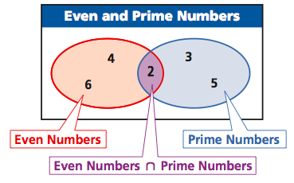

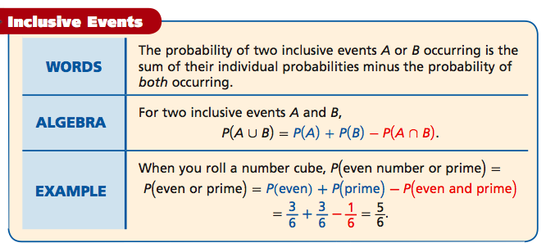

I Try:

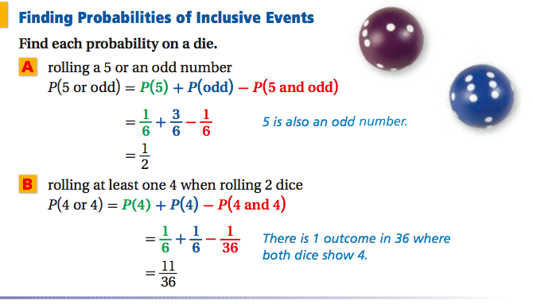

We Try:
- What is the probability of drawing a king or a heart from a deck of cards?
- What is the probability of drawing a red card or a face card?

You Try:
- What is the probability of drawing a black card or an Ace?
- What is the probability of rolling a prime or even number on a single number cube?

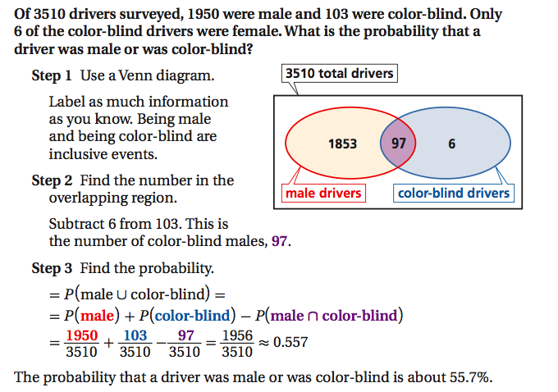

Using the complement.
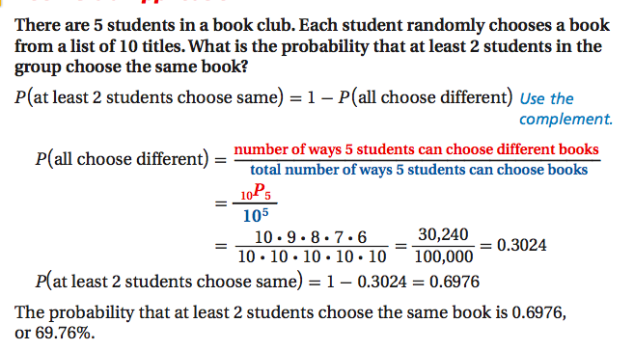

We Try:
In one day, 5 different customers bought earrings from the same jewelry store. The store offers 62 different styles. Find the probability that at least 2 customers bought the same style.

You Try:
There are 33 students in this class, what is the probability that at least 2 students share the same birthday?

Closure:
Explain to your partner:
- What is the difference between inclusive and exclusive events?
- What is the formula to find inclusive events.
- What is the formula to find exclusive events.
- What is the probability that you will roll an odd number or a prime number on a single die?

