Independent and Dependent Events
11.3
Events are Independent Events if the occurrence of one event does not affect the probability of the other.

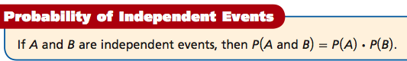
Coin tosses are independent events.
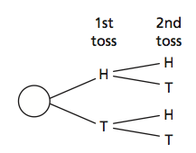

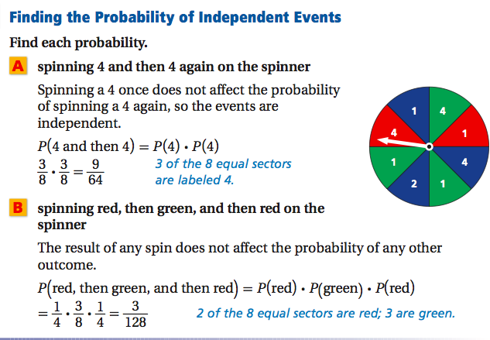

We Try:
- What is the probability of rolling a 6 and then an odd number a die?
- What is the probability of rolling an odd number and an even number on a die.
- What is the probability of drawing a numbered card in a normal deck of cards and rolling an even number on a die?

You Try:
- What is the probability of drawing a diamond and flipping heads on a quarter?
- What is the probability of flipping a tails and then rolling a 7 on a normal 6 sided die?
- What is the probability of rolling an odd number and drawing a 3 from a deck of 52 cards.

Events are Dependent events if the occurrence of one event affects the probability of the other.

To find the probability of dependent events, you can use Conditional probability P(B|A), the probability of event B, given that event A has occurred.

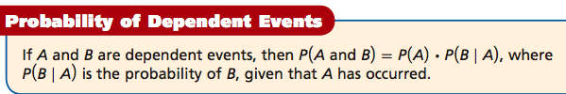

Choosing 2 pieces of fruit from a bag containing 2 lemons and a lime is a dependent event.
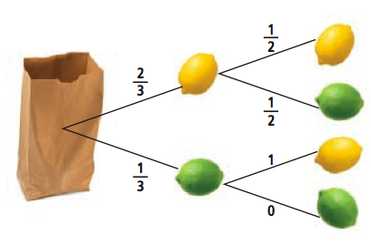

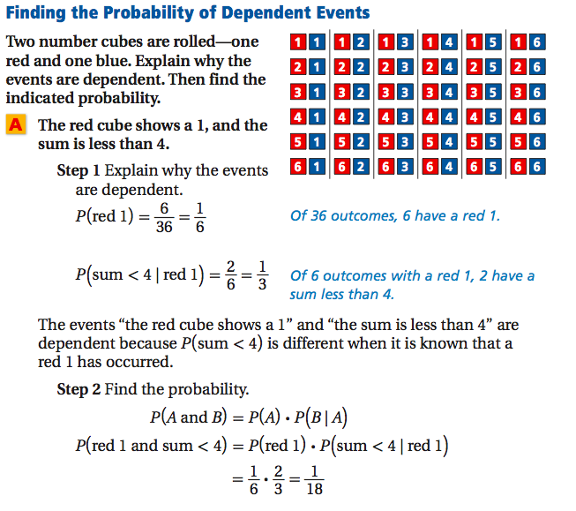

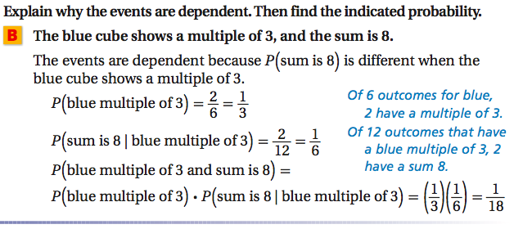

We try:
- What is the probability that the red cube shows a number greater than 4, and the sum is greater than 9?

- What is the probability that the red cube shows a number less than 3, and the sum is less than 5.

- What is the probability that the red cube is even, and the sum is greater than 6?

You Try:
After two dice, what is the probability that:
- The first die is 3, and the sum is greater than 5.
- The first die is 2, and the sum is less than 6.
- The first die is odd and the sum is 5.

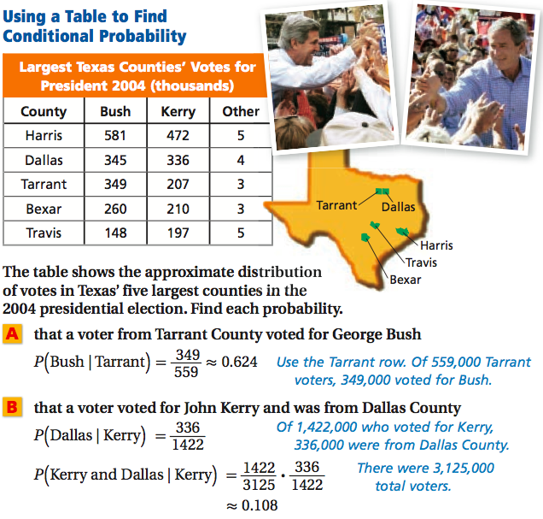

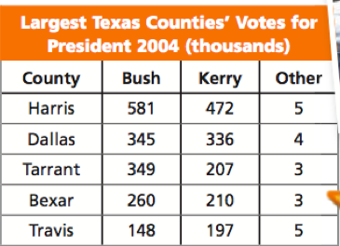

We Try:
1) Find the probability that a voter from Travis county voted for someone other than George Bush or John Kerry.

2) Find the probability that a voter was from Harris county and voted for George Bush.

You Try:
- Find the probability that a person from Bexar voted for Bush.
- Find the probability that a person who voted for Bush was from Bexar.

In many cases involving random selection, events are independent when there is replacement and dependent when there is not replacement.

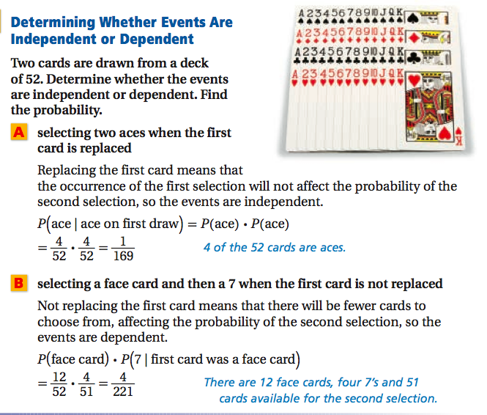

We Try:
A bag contains 10 beads-2 black, 3 white, and 5 red. A bead is selected at random. Determine whether the events are independent or dependent. Find the probability.

- Selecting a white bead, replacing it, and then selecting a red bead.
- Selecting a white bead, not replacing it, and then selecting a red bead.
- Selecting 3 non-red beads without replacement.

You Try:
A bag contains 10 beads-3 black, 2 white, and 5 red. A bead is selected at random. Determine whether the events are independent or dependent. Find the probability.

- Selecting a red bead, replacing it, and then selecting a black bead.
- Selecting a black bead, not replacing it, and selecting a black bead.
- Selecting 4 non-black beads without replacement.

Closure:
Discuss with your partners.
- What is the difference between independent and dependent events.
- You roll two dice. What is probability that the first cube shows a number greater than 4, and the sum is greater than 9?

