Probability Intro
11.1
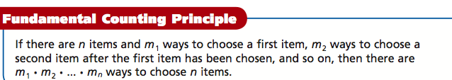

Mr. Yen is not only a teacher of humility or a master sail crafter or a musician, but during the summer break, Mr. Yen is a co-owner of a restaurant. Please help Mr. Yen find out the possible lunch special combinations if you can have one of each entrée, side dish, and drink. 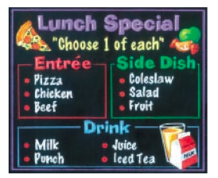

#2 I do:
In Utah, a license plate consists of 3 digits followed by 3 letters. The letters I,O,U are not used, and each digit or letter may be used more than once. How many different license plates are possible?

#3 We do:
A “Make your own adventure” store lets you choose 6 starting points, gives 4 plot choices, and then has 5 possible endings. How many adventures are there?

#4 You do:
A password is 4 letters followed by 1 digit. Uppercase letters and lowercase letters may be used and are considered different. How many passwords are possible?

